A/PROF JEREMY GRUMMET
MBBS, MS, FRACS

CV JUNE 2019
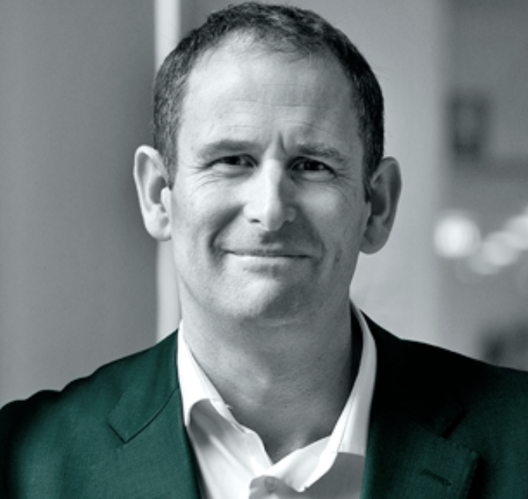
Current Positions
2008- VMO Urologist
2014- Supervisor of PhD and Master of Surgery researchers
2015- Clinical Associate Professor, Department of Surgery, Monash University
2017- Director of Clinical Research in Urology at Alfred Health
2017- European Association of Urology (EAU) Guidelines Prostate Cancer Panel Member
2017- Co-Founder of MRI PRO – an online prostate MRI training program for specialists

Training
1996: MBBS, University of Melbourne
2004: Master of Surgery, University of Melbourne
2007: FRACS (Urol)
2007-8: Clinical Uro-Oncology Fellowship: The Prostate Centre at Vancouver General Hospital, University of British Columbia, Canada

Clinical Trials
2015- : Concept creator and Principal Investigator (CIB) of Painfree TRUS B ANZUP RCT. Awarded $600,000 competitive funding from Cancer Australia and PCFA
2018- : Concept creator and Principal Investigator of the Monash University SAMURAI Study on PSMA PET/MRI in diagnosis and localisation of prostate cancer
2015-8: Site investigator for ENZAMET ANZUP RCT, results published in NEJM June 2019

Research Supervision
2017-9: Monash University PhD student: MRI in Prostate Cancer Diagnosis (Dr Rowan Miller – in progress)
2019- : Monash University Bachelor of Medical Science student: The Role of PSMA PET/MRI in the Diagnosis and Localisation of Prostate Cancer – the SAMURAI Study (Jeremy Cheng – in progress)
2018: Monash University Bachelor of Medical Science student: The Role of PSMA PET/MRI in the Diagnosis and Localisation of Prostate Cancer – the SAMURAI Study (Henry Pan – completed with 1st Class Honours)
2017: Monash University Master of Surgery student (co-supervisor): Functional Outcomes Post Local Treatment of prostate Cancer (Dr Luke Wang – candidature withdrawn)
2015-17: Monash University Master of Surgery student: The Role of MRI in Prostate Cancer Diagnosis (Dr Sean Huang - completed)
2014: Monash University Bachelor of Medical Science student: TRUS Biopsy Sepsis (Elliot Anderson - completed)

Prizes
2017: Alban Gee Prize for Best Poster at 2017 USANZ ASM - Robotic MRI-ultrasound fusion transperineal biopsy using the iSR’obot Mona Lisa: technique, safety and accuracy
2016: Epworth Peter J Dohrmann Prize for Transperineal Biopsy for Prostate Cancer
2015: Lead author of BJUI Global Prize-winning publication - Sepsis and Superbugs: Should we favour the transperineal over the transrectal approach for prostate biopsy?
2008: CUA Annual Meeting, Edmonton, Canada - Five Star Distinction for Radical Prostatectomy for High Risk Prostate Cancer: the Vancouver Experience
2008: GU-ASCO, San Francisco, California – Merit Award for Radical Prostatectomy for High Risk Prostate Cancer: the Vancouver Experience

Top 10 Publications

Can Video Conferencing Facilitate Better Discharge Processes and a Superior Patient Experience?
Grummet J, Wickramasinghe N, Haddad P, O'Connor L.
Stud Health Technol Inform. 2017;245:1360.

Prognostic Value of Biochemical Recurrence Following Treatment with Curative Intent for Prostate Cancer: A Systematic Review.
Van den Broeck T, van den Bergh RCN, Arfi N, Gross T, Moris L, Briers E, Cumberbatch M, De Santis M, Tilki D, Fanti S, Fossati N, Gillessen S, Grummet JP, et al.
Eur Urol. 2019 Jun;75(6):967-987.

Multicentre evaluation of magnetic resonance imaging supported transperineal prostate biopsy in biopsy-naïve men with suspicion of prostate cancer.
Hansen NL, Barrett T, Kesch C, Pepdjonovic L, Bonekamp D, O'Sullivan R, Distler F, Warren A, Samel C, Hadaschik B, Grummet J, Kastner C.
BJU Int. 2018 Jul;122(1):40-49.

How to Biopsy: Transperineal Versus Transrectal, Saturation Versus Targeted, What's the Evidence?
Grummet J.
Urol Clin North Am. 2017 Nov;44(4):525-534.

Transperineal vs. transrectal biopsy in MRI targeting.
Grummet J, Pepdjonovic L, Huang S, Anderson E, Hadaschik B.
Transl Androl Urol. 2017 Jun;6(3):368-375.

Prostate Biopsy-related Infection: A Systematic Review of Risk Factors, Prevention Strategies, and Management Approaches.
Roberts MJ, Bennett HY, Harris PN, Holmes M, Grummet J, Naber K, Wagenlehner FME.
Urology. 2017 Jun;104:11-21.

Zero hospital admissions for infection after 577 transperineal prostate biopsies using single-dose cephazolin prophylaxis.
Pepdjonovic L, Grummet J, et al.
World J Urol. 2017 Aug;35(8):1199-1203.

Planning for the post-antibiotic era - why we must avoid TRUS-guided biopsy sampling.
Murphy DG, Grummet JP.
Nat Rev Urol. 2016 Oct;13(10):559-60

The state of TRUS biopsy sepsis: readmissions to Victorian hospitals with TRUS biopsy-related infection over 5 years.
Roth H, Millar JL, Cheng AC, Byrne A, Evans S, Grummet J.
BJU Int. 2015 Oct;116 Suppl 3:49-53.

Sepsis and 'superbugs': should we favour the transperineal over the transrectal approach for prostate biopsy?
Grummet JP, Weerakoon M, Huang S, Lawrentschuk N, Frydenberg M, Moon DA, O'Reilly M, Murphy D.
BJU Int. 2014 Sep;114(3):384-8. *BJUI Global Prize

Other Achievements

2013 Established the Victorian Transperineal Biopsy Collaboration for multi-centre research
2014 Established the Epworth Richmond Prostate MRI Multidisciplinary Clinical Meeting
2017 Invited speaker on Transperineal Biopsy in the plenary session of the world’s largest urology conference, the American Urology Association (AUA) ASM in Boston

